LARYNGECTOMEES and COVID SURVEY
About the survey
NALC assisted with a survey in January 2021 to seek laryngectomee experiences of the Covid pandemic.
37 responses were received. 24 respondents were male, 8 female and 5 did not share this information.
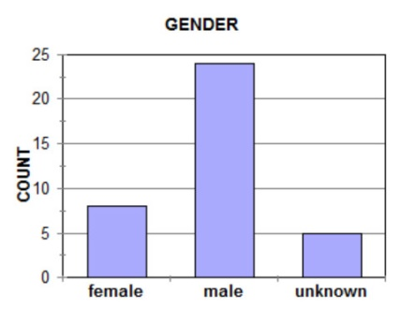
Respondents came from England and Scotland.
Were laryngectomees’ lives affected by the Covid pandemic?
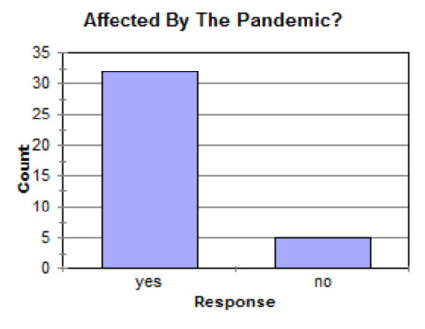
Over 85% of respondents felt their lives were affected by the pandemic. 70% found their access to healthcare, especially valve services, was much restricted. Over 40% also mentioned the reduction in social contact.
Support Received During the Pandemic
The survey asked about the level of support received and who provided it. Over 30 were supported but six had no support. Of the 6, 3 were happy with this. Around half were satisfied with the support they received but over 40% were not. Two people did not provide an answer.
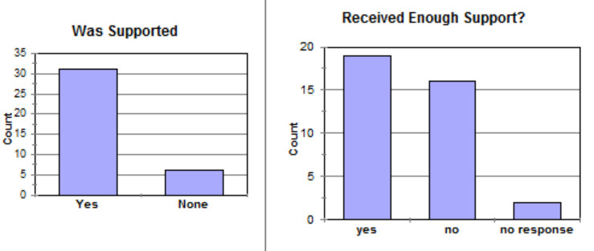

They were also asked who provided support to them and some mentioned where support was lacking. The graph shows the number of mentions for each type of clinician. Additionally, 6 reported a lack of support from their GP.
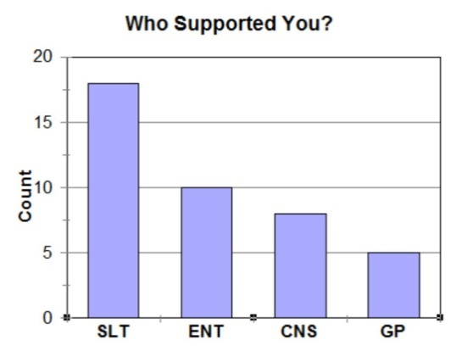
Other sources of assistance mentioned were NALC, ATOS and local support groups.
(In some trusts, valve services are provided by the CNS)
Anxieties and Fears
The vast majority of respondents shared experiences of anxiety and fear during the pandemic, when asked.
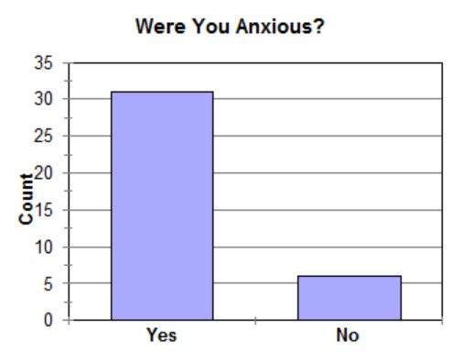
Half of those admitting to some anxiety did not specify its nature. Of those that did, many expressed a fear of catching Covid or of going to hospital, but more described a generalised state of anxiety.
Around 75% described a coping mechanism, with discussing and sharing with others being the most common. Many mentioned the importance of following the guidance and around 10% had needed to seek professional assistance with handling their mental state.
Same Again?
When asked how they would deal with a similar situation in the future, two thirds said they would do the same themselves as they had done so far during the pandemic. However around one third expressed the hope for better support.
Conclusions
This was a a simple broad brush survey but there are perhaps a couple of points that stand out. The laryngectomee community has had great support from SLTs, and that is appreciated. GP services have been under massive pressure but there is much disappointment in how they have helped us with handling Covid.

